Component creation 3

## Components are calling inside another components

Creating some components bodycomponent, title , navbar and button

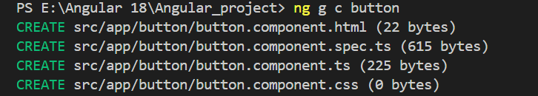

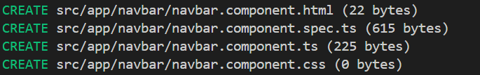

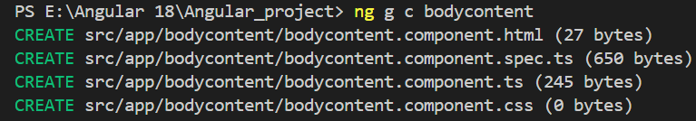

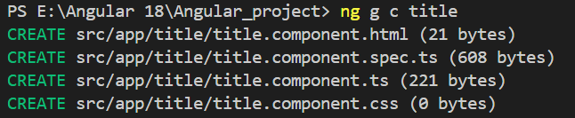

* The **app.component.html** only calling the bodycontent component

<app-bodycontent></app-bodycontent>

* To call this first add that component in the **app.component.ts** import section

  imports: [BodycontentComponent],

**app.component.ts**

import { Component } from '@angular/core';

import { RouterOutlet } from '@angular/router';

import { BodycontentComponent } from './bodycontent/bodycontent.component';

@Component({

  selector: 'app-root',

  imports: [BodycontentComponent],

  templateUrl: './app.component.html',

  styleUrl: './app.component.css'

})

export class AppComponent {

  title='Angular_project';

}

All the editing components are calling in Bodycontent component

**Bodycontent > bodycontent.component.html**

<div class="body-content">

  <div class="navbar">

<app-navbar></app-navbar>

</div>

  <div class="body-content-inner" style="display: flex; flex-direction: column; justify-content: center">

    <app-title></app-title>

    <div class="buttons">

        <app-button></app-button>

    </div>

  </div>

</div>

**Bodycontent > bodycontent.component.css**

.body-content {

    background-image: url("https://static.vecteezy.com/system/resources/previews/029/467/026/non_2x/generative-ai-hot-cappuccino-with-latte-art-on-wooden-table-with-coffee-beans-photo.jpg");

    background-size: cover;

    width: 100%;

    height: 100vh;

    color: white;

    text-align: center;

  }

  .body-content-inner {

    max-width: 100%;

    height: 100vh;

    text-align: center;

    display: block;

    margin: 0 auto;

  }

**Navbar > Nabar.component.html**

<nav class="navbar">

  <span>Coffeehouse</span>

  <ul>

    <li><a href="#home">Home</a></li>

    <li><a href="#about">About</a></li>

    <li><a href="#services">Services</a></li>

    <li><a href="#contact" id="last">Contact</a></li>

  </ul>

</nav>

**Navbar > navbar.component.css**

.navbar {

    width: 100%;

    background-color: rgb(56, 17, 17);

    display: flex;

    justify-content: space-between;

    align-items: center;

  height: 80px;

  }

  li {

    display: inline-block;

    text-decoration: none;

  }

  a {

    text-decoration: none;

    color: white;

    font-size: 25px;

  }

  ul {

    display: flex;

    gap: 20px;

  }

  span{

  margin-left: 30px;

  font-size: 35px;

  font-weight: bold;

  }

  #last{

  margin-right: 30px;

  }

**Title > title.component.html**

<h1 style="-webkit-text-stroke: 3px rgb(88, 6, 6)">Welcome to Our Cafe Website</h1>

<h2 style="-webkit-text-stroke: 1px black">Your Satisfaction is our priority</h2>

**Title > title.component.css**

 h1 {

    font-size: 4.5em;

    margin-bottom: 0.5em;

  }

 h2 {

    font-size: 1.5em;

    margin-bottom: 1em;

  }

**Button >button.component.html**

<button class="btn btn-primary">Learn More</button>

<button class="btn btn-secondary">Contact Us</button>

Button > button.component.css

.buttons {

    margin-top: 20px;

  }

  .btn {

    padding: 10px 20px;

    margin: 8px;

    border: none;

    cursor: pointer;

    font-size: 1.5em;

    border-radius: 5px;

  }

  .btn-primary {

    background-color: #9e0202;

    color: white;

  }

  .btn-secondary {

    background-color: #0963b1;

    color: white;

  }

  .btn-primary:hover,

  .btn-secondary:hover {

    opacity: 0.8;

  }

**OutPut :**

